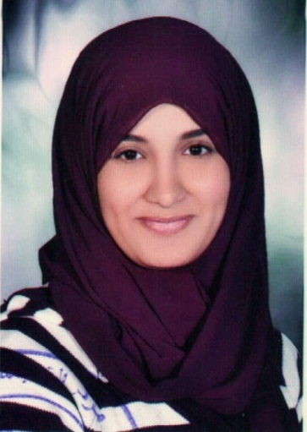
Biography
Sarah Ibrahim Hamed

Personal Information:
Name: Sarah Ibrahim Hamed Khalaf Allah
Position: Lecturer of Archaeology Faculty of Arts, Asyut University.
Date of Birth: 02/05/1991
place of birth: Asyut
Religion: Muslim
Marital status: Miss
Address: July 26 Street New Awqaf Building Entrance B Flat 10
Major: Islamic monuments
Specialization: Islamic Arts
Phone home: 0882352587
Mobile phone: 01100071331
Work Phone: 0882323000 (internal 5254)
Business Fax: 0882328515
E-mail: sara.islamicart@yahoo.com

Qualifications:
• Bachelor of Arts - Department of Archaeology Faculty of Arts - Asyut University grade "very good" in 2011.
• Pre-master of the Department of Archaeology Faculty of Arts, Asyut University - in 2012.
International conferences:
• Audience participation in the first Conference of the Islamic impacts in the Muslim East Faculty of Antiquities, Cairo University in the period from December 8 to 12, 2013 m.
• Audience participation in the seventeenth conference of the General Union of Arab Archaeologists 1 to 3 November 2014 m, Sheikh Zayed, Cairo.
Membership of scientific associations:
• Member of the Union of Arab Archaeologists
• Member of the Egyptian Society for Historical Studies.
Practical and Student Activities:
• Subscribe to the scientific supervision of the annual scientific trips for students of effects "Division Islamic monuments" section at the Faculty of Arts - University of Asyut to different cities Egypt: Cairo - Alexandria - Rashid - fowa "
Scientific lectures:
• The lecture at the Library of Alexandria within the activities of Essam Mohammed Shanti session "indexing Arab manuscript" in the period from May 12 to 16, 2013, under the title: "Binding and the Arts manuscript."

